About:

Hello, I am Mohammad Akib Islam from Bangladesh. Currently I am a student of Building Engineering & Construction Management (BECM) from Rajshahi University of Engineering & Technology. I want to pursue my field of study by trying to bring more innovative and complex designs both in the internal and external feature of any building. After I graduate, I want to devote my time to developing numerous building design scenarios and upholding Bangladesh's building codes.

Professional Experience:

Language Efficiency:

* Bangla

Level of Expertise: Native

* English

Level of Expertise: Fluent.

* German.

Level of Expertise: Basic.

* Hindi

Level of Expertise: Verbal

* O Level Mathematics Tutor.

Duration: October 2022-March 2023

* Industrial Attachment

Duration: April, 2022

* Personal IELTS Instructor.

Duration: 2021-2022

* Personal Mentor

Duration: 2018-2020

Contact Information:

+880 1875 347963

writingakib@gmail.com

<https://www.facebook.com/akib0.o>

+880 1875 347963

[@__akib](https://twitter.com/__akib)

www.linkedin.com/in/mohammad-akib-islam-7a15a2200

House 21, Road 05, Sector 10, Uttara Dhaka 1230.

Computer Efficiency:

* Autodesk AutoCAD, Revit.
* SketchUp.
* Adobe Illustrator.
* Adobe Photoshop.
* MS Project.
* eTabs.
* Wondershare.
* Lumion.

Academic Qualifications:

**B.Sc. in Building Engineering & Construction Management.**

Rajshahi University of Engineering & Technology.

Result: 3.10 out of 4.00

Extracurricular Activity/Achievement: * Vice President, Dhaka Nibashi Somitte.

* Executive Member, RUET Career Forum.

* General Member, RUET Annexa.

* Executive Member, Notre Dame Student’s Association of

RUET.

**Higher Secondary Certificate.**

Notre Dame College.

Result: 5.00 out of 5.00

Extracurricular Activity/Achievement: * Executive Member, Notre Dame Nature Club.

* Volunteer at International Green Inspiration Fest.

* Member, Notre Dame Science Club.

**Secondary School Certificate.**

Rajuk Uttara Model School & College.

Result: 5.00 out of 5.00

Extracurricular Activity/Achievement: * Member, Rajuk College Photography Club.

* Disciplined Student Certification.

**Junior School Certificate.**

Rajuk Uttara Model School & College.

Result: 5.00 out of 5.00

Extracurricular Activity/Achievement: * Member, Rajuk College Physics Club.

* Qualified for Dutch Bangla Bank National Mathematics

Olympiad at School Level.

Online Certifications (Coursera):

1. Fundamentals of Graphic Design, California Institute of the Arts.
2. Leadership and Emotional Intelligence, Indian School of Business.
3. Design Thinking for Innovation, University of Virginia.
4. Electric Vehicles and Mobility, École des Ponts ParisTech.
5. Initiating and Planning Projects, University of California, Irvine.
6. Renewable Energy and Green Building Entrepreneurship, Duke University.
7. Engineering Project Management: Scope, Time and Cost Management, Rice University.
8. Professional Skills for International Business, University of London.
9. Teamwork Skills: Communicating Effectively in Groups, University of Colorado Boulder.

Designs and Plans:

All through my educational tenure I completed the below mentioned models and plots which reflects my thoughts and views in Building Construction.

Multipurpose Bungalow

The bungalow offers a flexible living area to meet your needs with five well planned rooms, each radiating its own special character. Every part of this home welcomes you to feel the highest comfort and tranquilly, from cosy bedrooms decorated with luxurious furniture to expansive living areas flooded with natural light. This amazing home has not one, but two garages, giving you plenty of room for your cherished cars and storage needs. You'll find a wonderful swimming pool as you wander around the vast grounds; it begs you to spend lazy days by the pool. But what really makes this bungalow stand out is its extraordinary and breathtaking design. This building enters a different level due to the blending of modern and traditional components and the superb craftsmanship. Get ready to be mesmerized by the perfect balance of streamlined lines, sweeping arches, and decorative flourishes that make this house a masterpiece. Welcome to a world where elegance, adaptability, and flawless design coexist together.

Simplifying and Ergonomic

The façade of the bungalow impresses with clean lines, stunning geometric shapes, and a seamless integration of glass and metal, which together produce a striking visual impression. Its interior is a testament to contemporary luxury, featuring open-concept living spaces, high ceilings, and an abundance of natural light that illuminates the exquisite finishes and state-of-the-art fixtures. It also has an abundance of natural light that floods the space. A genuinely one-of-a-kind and enthralling way to spend one's time at home has been painstakingly created into each and every inch of this charming house.

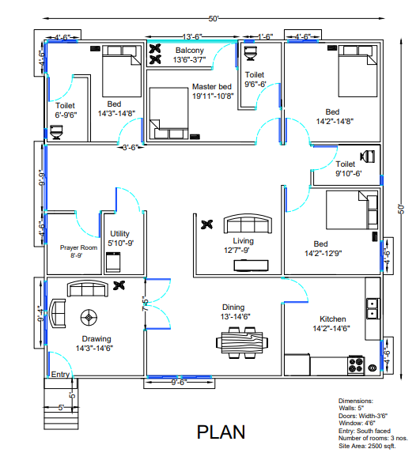

The design of this singularly faced building was meticulously crafted with a primary focus on embracing the elegance of a square form. Each room within its structure boasts an impressive uniformity, almost identical in layout and amenities, reflecting a harmonious balance. Furthermore, thoughtful consideration was given to the occupants' comfort and mobility, as ample free space was thoughtfully integrated into the blueprint, promoting ease of personal locomotion. The result is a stunning architectural marvel that not only captivates with its visual symmetry but also caters to the practical needs of its inhabitants, fostering an atmosphere of coherence and functional bliss.

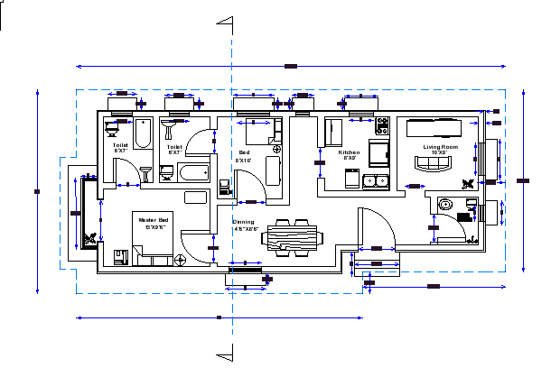

This meticulously designed plan prioritizes maximum comfort and solitude within tight space constraints. The symmetrical arrangement of rooms ensures a balanced and harmonious ambiance. To enhance the overall well-being, ample openings have been strategically placed to allow an abundance of natural light and fresh air to permeate the living spaces. The seamless integration of these elements creates an inviting and tranquil environment, promoting relaxation and peace of mind. This thoughtfully crafted design aims to optimize the limited space while maintaining a sense of spaciousness and harmony, resulting in a perfect haven for comfort and solace.

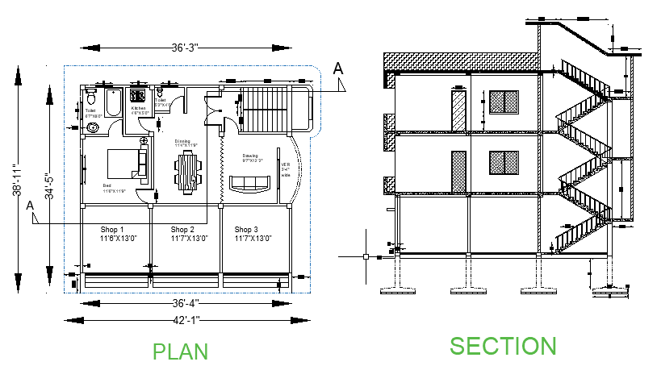

This peaceful retreat offers unmatched comfort and privacy. Every detail is carefully planned for restful nights and a pleasant atmosphere. Soft-toned walls promote relaxation and restful sleep. The room has elegant, luxurious furnishings. Carefully chosen décor adds peace and creates a true hideaway from the outside world. The master bedroom's private balcony encourages nature lovers to relax. Every feature in this comfortable and secluded retreat works together to provide a peaceful and revitalizing vacation from daily life.

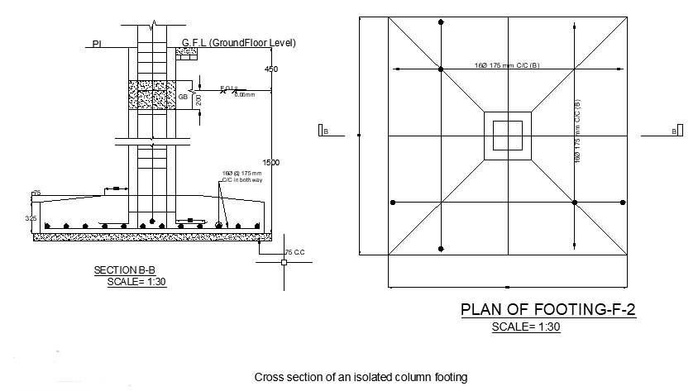

A firm footing distributes loads from a building or structure to the ground, ensuring its stability. It evenly distributes loads across a broader area to prevent settling and ensure the construction's safety and integrity. Many building projects use reinforced concrete footings due to their longevity and strength. The type of soil at the construction site, the size and weight of the structure it will support, and the estimated loads or pressures it will endure must be considered when building these footings. Footing design depends on soil type. Footing design must account for soil load-bearing capacities to avoid sinking or settling. Engineers and geotechnical professionals examine and analyze soil characteristics to identify the best site footing. Footing design also depends on structural size and weight. Heavy buildings need stronger footings to distribute loads. Taller buildings must withstand more vertical loads, which can affect design.

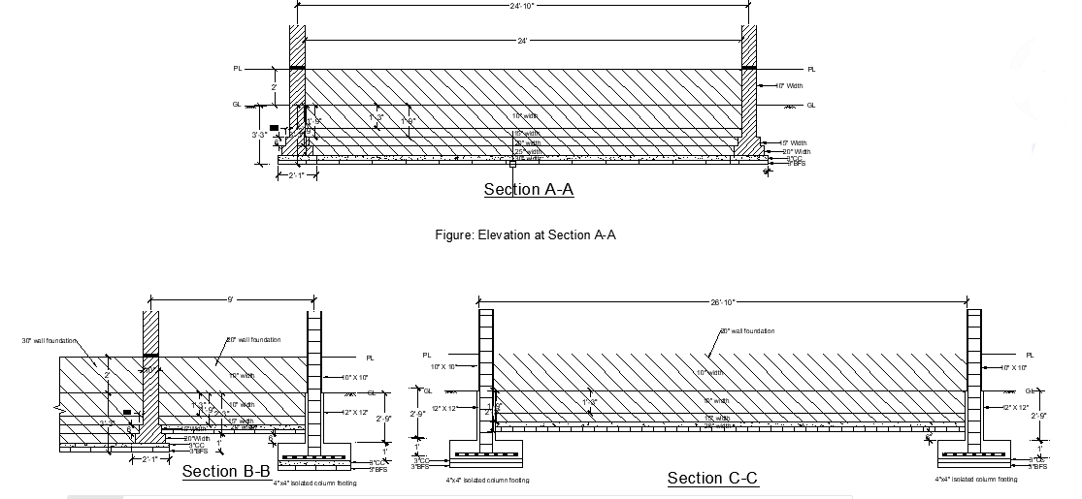

It is usual practice to employ materials consisting of masonry or reinforced concrete when constructing the foundations of walls when doing construction work. They are constructed to be broader than the wall that they are providing support for in order for them to be able to offer stability and distribute the weight over a larger area of the ground. The width and depth of the foundation are impacted in a number of different ways by a range of factors, some of which include the kind of soil, the height of the wall, and the weights that it will hold. The width and depth of the foundation are also impacted in a number of different ways by a variety of other factors.

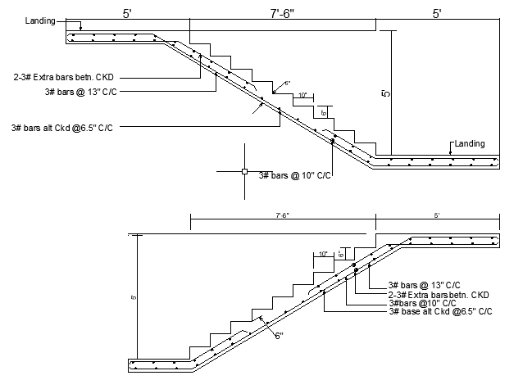

Reinforcement in stairs is crucial to enhance their structural integrity and safety. Proper orientation and placement of rebars ensure that the stairs can withstand heavy loads and prevent cracking or collapsing over time. Vertical rebars are strategically positioned within the stair risers and treads to resist tension and bending forces. Additionally, horizontal rebars are incorporated to provide lateral support and distribute loads evenly. Adequate concrete cover is maintained to protect the rebars from corrosion. Following industry standards and design guidelines ensures that the reinforcement is optimally arranged, granting the stairs the required strength and durability for their intended use.

Below shown a working drawing of a six storied residential building with all details and specifications which I made by using all the codes and information as per BNBC and local guidelines.

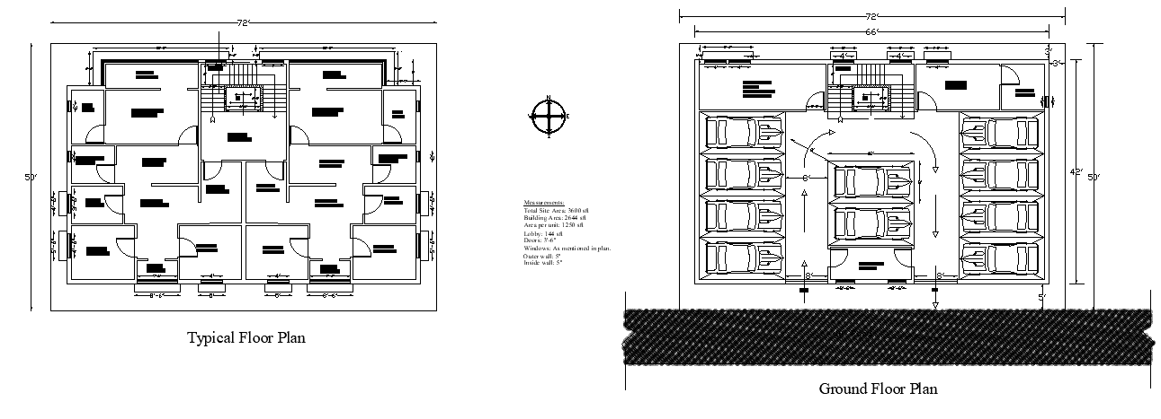

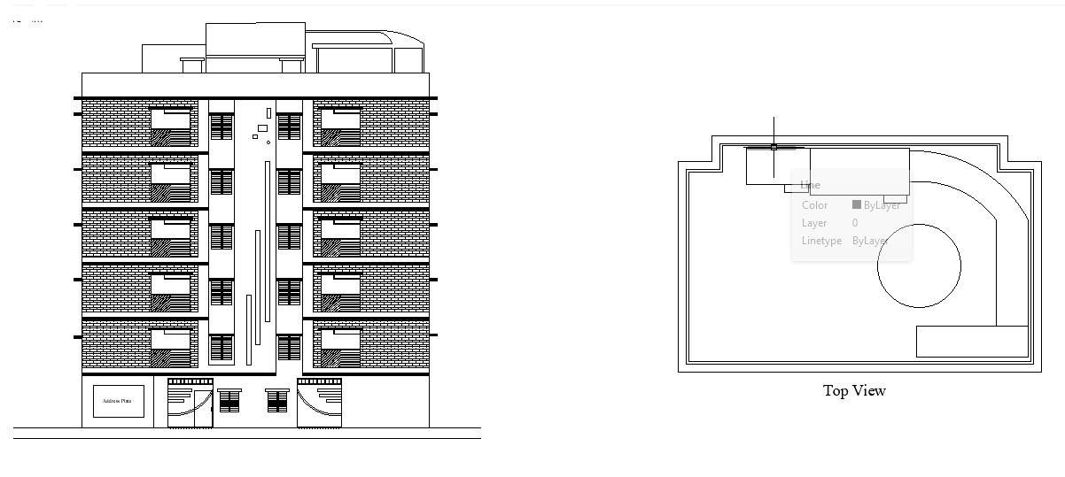

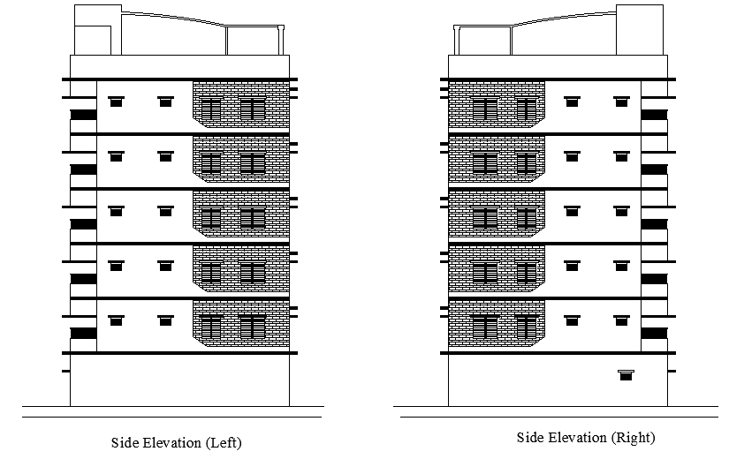

Publications:

* Mehedi Hassan, Mohammad Akib Islam, Shahriar Bin Rafique (2023), *A definite approach towards smart classroom equipped with proper acoustical treatment, HVAC, structural arrangement and human psychology.*
* Mohammad Akib Islam, Enamul Hossain Shwagato (2023), *Design and Implementation of a Sustainable On-Site Sewage Management System for Building Construction with combining Drainage Channels and Composting Facilities and Recycling abilities.*
* Tanvin Mahi, Niloy Hoque, Mohammad Akib Islam (2023), *Implementations, Challenges and Advancement of Agile Project Management in Modern Projects.*

References:

i. Mehedi Hassan..

Assistant Professor.

Department of Building Engineering and Construction Management.

Mail: <mehedi@becm.ruet.ac.bd>

ii. Md. Shafiqul Islam.

Chief Engineer.

Associated Builders Corporation Limited.

Mail: <shafiqulislam59@gmail.com>

iii. Prof. Md. Dr. Rabiul Awal.

Head of the Department.

Department of Building Engineering and Construction Management.

Mail: <robi95@ce.ruet.ac.bd>